University of North Texas

Department of Sociology

SOCI 3200: Introduction to Sociological Theory

Instructor: Shahab Razaghipoor

Email: ShahabRazaghipoor@my.unt.edu

Virtual Office Hours: Wednesday 2-4 PM

Zoom: https://unt.zoom.us/j/3706708310

This course provides an introduction to sociological theory from the 1840s to the present day, though it concentrates on the classical era of sociological theory from the Industrial Revolution through World War I. The course provides a foundation for taking 3000- and 4000-level sociology courses, and it is intended primarily, although not exclusively, for sociology majors and minors.

Textbook: Social Theory: Roots & Branches 6th Edition by Peter Kivisto.
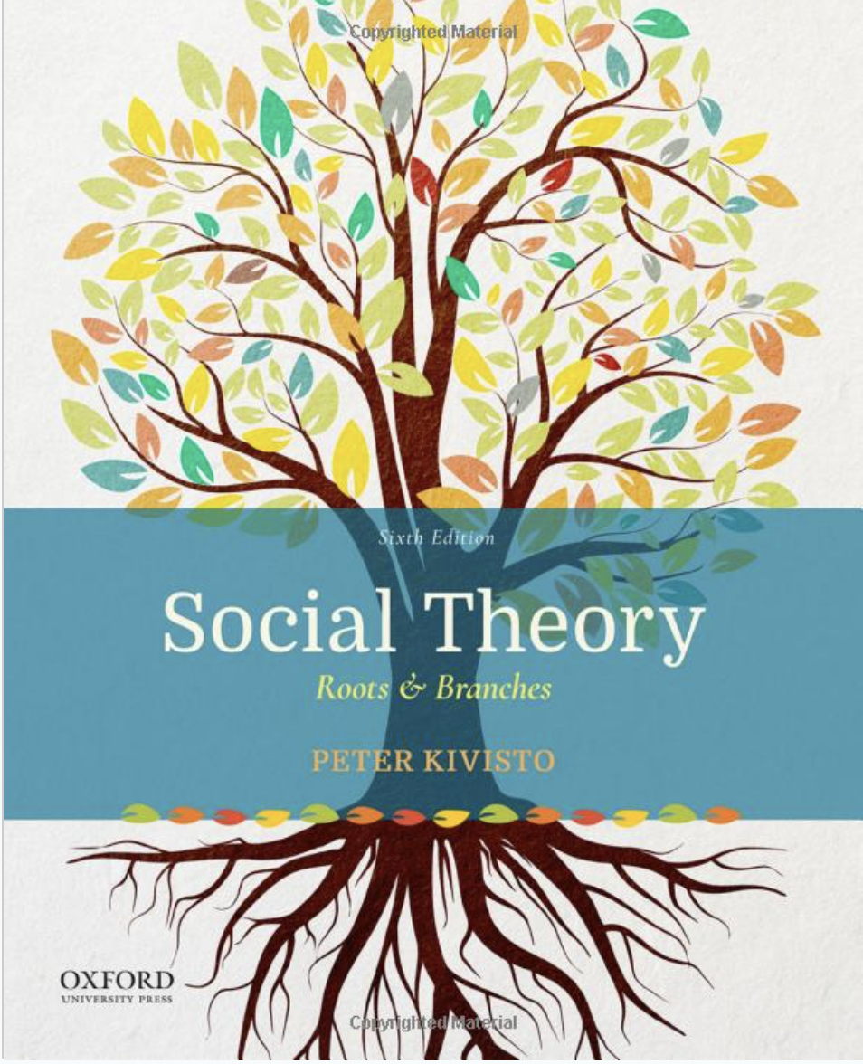

Minimum Technology Requirements for the Course:

• Computer

• Reliable internet access

• Microsoft Office Suite

• Canvas Technical Requirements (https://clear.unt.edu/supported-technologies/canvas/requirements)

Technical Assistance

Part of working in the online environment involves dealing with the inconveniences and frustration that can arise when technology breaks down or does not perform as expected. Here at UNT we have a Student Help Desk that you can contact for help with Canvas or other technology issues.

UNT Help Desk: (http://www.unt.edu/helpdesk/index.htm)

Email: helpdesk@unt.edu

Phone: 940-565-2324

In Person: Sage Hall, Room 130

Walk-In Availability: 8am-9pm

Telephone Availability:

• Sunday: noon-midnight

• Monday-Thursday: 8am-midnight

• Friday: 8am-8pm

• Saturday: 9am-5pm

Laptop Checkout: 8am-7pm

For additional support, visit Canvas Technical Help (https://community.canvaslms.com/docs/DOC-10554-4212710328)

Assignments and Grading:

This course has four types of assignments: A Pre- and Post-Course Evaluation, four exams, fourteen discussions, and a final essay. All discussions, testing and essay submissions will be done (and all grades will be posted) on the CANVAS site for this course.

Pre- and Post-Course Evaluation: The University is requiring all students to take a course evaluation at the beginning and end of the course. It is required for every student to take these and they will be worth 12.5 points each. These will be completion grades. As long as you complete these evaluations, you will receive these points. In total, 25 points.

Exams: There are four exams for this course—one about every three weeks--which must be completed by the due date specified on the syllabus. Exams will be posted on Canvas early in the week and can be taken at any time throughout the week (up until Friday by midnight). Each exam is worth 50 points. Each exam will consist of four short answer questions and you will have one hour and thirty minutes to complete each exam. Material will be drawn from previous weeks but are not concurrent with the week the exam is posted. For example, exam 3 is during the week we learn about Feminist Sociology, so it may include questions about all previous content but not questions about Feminist Sociology. In total, 200 points.

Discussion/Participation: You will be expected to engage in weekly discussions (not including finals week and not including the first week of class) of the assigned material, and this will take place on the course’s message board on Canvas.

Your posts on the message board can address any components of the assigned reading for the week—the content and perspective expressed in the post is up to you, so long as it directly relates to the readings for that week.

Your contributions on the message board must be interactive and engaging: consider the readings from different points of view, ask questions of your fellow students and comment reflectively on the posts of others. These weekly discussions are worth 10 points each. In total, 140 points.

You can access these discussions under the weekly modules in the “Modules” tab or under the “Discussions” tab.

Your discussion posts will be graded on the basis of how well they meet the following criteria:
- Full engagement:
  - Make (at least) one original post of at least 200 words each week.
  - Provide (at least) one response to your classmates’ posts each week of at least 50 words.

2) Make sure your posts are relevant to the topic(s) of the assigned chapters each week.

3) Make sure to incorporate/make specific reference to material from the text. When drawing directly from text material, put passages in quotations and cite text page numbers.

4) Emphasize your thoughtfulness and curiosity.

5) Watch spelling, grammar, and organization.

Feel free to give your thoughts and opinions, to ask questions of your classmates, and be ready to explain your point of view.

Essay: There is one essay in this course, which will be due during finals week (see the course schedule below). The essay should be composed of a full 10 pages (not including works cited, titles, etc.), be doubled-spaced, and use 12-point Times New Roman font. There is no title page required. If you want, you can create a works cited page for the textbook (since no outside material or reading is required) but it is not mandatory. You must always use proper in-text citations when quoting the textbook regardless of if you include a works cited page. The final essay is worth 200 points.

This essay will require the following components:
- Pick four of the readings in the class, and briefly summarize them. Keep the summaries short (1-2 pages total).
- Specify areas of agreement/synergy that you perceive across the readings as well as areas of disagreement/inconsistency that you perceive across the readings.
- Also, for each of the four readings you choose, specify what you found interesting or helpful to your understanding and/or what you found uninteresting or unhelpful/confusing.

No late work will be accepted without evidence of a documented, verifiable medical emergency.

Instances of plagiarism will result in an immediate F and referral to the Dean of Students.

Grading Scale:
A = 90 to 100% of all possible points
B = 80 to 89%
C = 70 to 79%
D = 60 to 69%
F = Below 60%

Academic Integrity:

It is the responsibility of each student to be familiar with UNT’s Policy on Academic Integrity. Plagiarism, copying, cheating, or giving assistance to other students during examinations is a violation of academic integrity. Cases of suspected cheating or plagiarism will be reported to the Dean of Students office. Note that any and all work submitted in order to meet the requirements of this course must be originally created for this course. In other words, you may not turn in anything submitted for another course and/or section of this course you have previously taken.

University Policy 06.003 states, “UNT promotes the integrity of learning processed and embraces the core values of trust and honesty. Academic integrity is based on educational principles and procedures that protect the rights of all participants in the educational process and validate the legitimacy of degrees awarded by the university. In the investigation and resolution of allegations of student academic dishonesty, the university’s actions are intended to be corrective, educationally sound, fundamentally fair, and based on reliable evidence.”

For more information on what constitutes plagiarism, as well as tips on citing your resources, visit www.plagiarism.org. If you require clarification on what counts as academic dishonesty, it is your responsibility to ask the instructor of the course.

Academic Accommodations:

The University of North Texas makes reasonable academic accommodation for students with disabilities. Students seeking accommodation must first register with the Office of Disability Accommodation (ODA) to verify their eligibility. If a disability is verified, the ODA will provide you with an accommodation letter to be delivered to faculty to begin a private discussion regarding your specific needs in a course. You may request accommodations at any time, however, ODA notices of accommodation should be provided as early as possible in the semester to avoid any delay in implementation. Note that students must obtain a new letter of accommodation for every semester and must meet with each faculty member prior to implementation in each class. For additional information see the Office of Disability Accommodation website at http://disability.unt.edu. You may also contact them by phone at (940) 565-4323.

Course Schedule*:

Week 1: 8/23-8/28 Topics: Classical Foundations, Contemporary Developments
- Read the syllabus (posted on Canvas) and email me with any questions, or, come see me during office hours on Zoom.
- Read Social Theory: Classical Foundations and Contemporary Developments in the Kivisto book.
- Take Sociological Theory Proficiency Exam (on Canvas) by Saturday, August 28 at midnight.

Week 2: 8/29-9/4 Topics: Introduction to Sociological Theory
- Readings (from Kivisto book):
  - What is a Social Fact? (Emile Durkheim)
  - Anomic Suicide (Emile Durkheim)
  - Alienated Labor (Karl Marx)
- Canvas Discussion

Week 3: 9/5-9/11 Topics: Classical Theoretical Perspectives
- Readings (from Kivisto book)
  - On Mechanical and Organic Solidarity (Emile Durkheim)
  - The Structure of the Societal Community (Talcott Parsons)
- Canvas Discussion

Week 4: 9/12-9/18 Topics: Classical Theoretical Perspectives
- Readings (from Kivisto book)
  - Society as Symbolic Interaction (Herbert Blumer)
  - Performances (Erving Goffman)
- Canvas Discussion
- Exam One on Canvas, Due 9/17 by 11:59pm

Week 5: 9/19-9/25 Topics: Shame and Repugnance
- Readings (from Kivisto book)
  - Shame and Repugnance (Norbert Elias)
  - Multiple Modernities (S.N. Eisenstadt)
  - On Living in a Liquid Modern World (Zygmunt Bauman)
- Canvas Discussion

Week 6: 9/26-10/2 Topics: Capitalism, Urbanization, and Social Conflict Pt. 1
- Readings (from Kivisto book)
  - Class, Status, Party (Max Weber)
  - Conspicuous Consumption (Thorstein Veblen)
  - Bureaucracy (Max Weber)
  - The Spirit of Capitalism (Max Weber)
  - Manifesto of the Communist Party (Karl Marx & Fredrich Engels)
- Canvas Discussion

Week 7: 10/3-10/9 Topics: Capitalism, Urbanization, and Social Conflict Pt. 2
- Readings (from Kivisto book)
  - On Individualism (Alexis de Tocqueville)
  - Individualism and the Intellectuals (Emile Durkheim)
  - Structures and Habitus (Pierre Bourdieu)
  - The Metropolis and Mental Life (Georg Simmel)
- Canvas Discussion
- Exam Two on Canvas, Due 10/8 by 11:59pm

Week 8: 10/10-10/16 Topics: Major American Theorists
- Readings (from Kivisto book)
  - Of Our Spiritual Strivings (W.E.B. Dubois)
  - Situated Actions and Vocabularies of Motive (C. Wright Mills)
  - The Unanticipated Consequences of Social Action (Robert K. Merton)
  - What Pragmatism Means (William James)
- Canvas Discussion

Week 9: 10/17-10/23 Topics: Major American Theorists
- Readings (from Kivisto book)
  - The Fusion of the 'I' and the 'Me' in Social Activities (George Herbert Mead)
  - Social and Individual Aspects of the Mind (Charles Horton Cooley)
- Canvas Discussion

Week 10: 10/24-10/30 Topics: Feminist Sociology
- Readings (from Kivisto book)
  - Doing Gender (Candace West & Don H. Zimmerman)
  - Toward an Afrocentric Feminist Epistemology (Patricia Hill Collins)
  - The Dependence of Women (Charlotte Perkins Gilman)
- Canvas Discussion
- Exam Three on Canvas, Due 10/29 by 11:59pm

Week 11: 10/31-11/6 Topics: Cultural Theory
- Readings (from Kivisto book)
  - Freudian Theory and the Pattern of Fascist Propaganda (Theodor W. Adorno)
  - Advertising (Jean Baudrillard)
  - Nationalism and the Cultures of Democracy (Craig Calhoun)
- Canvas Discussion

Week 12: 11/7-11/13 Topics: Symbolic Interactionism and Structuralism
- Readings (from Kivisto book)
  - Interactional Ritual Theory (Randall Collins)
  - The Stranger: An Essay in Social Psychology (Alfred Schutz)
  - Studies of the Routine Grounds of Everyday Activities (Harold Garfinkel)
- Canvas Discussion

Week 13: 11/14-11/20 Topics: Exchange Theory
- Readings (from Kivisto book)
  - Social Behavior as Exchange (George C. Homans)
  - Formulation of Exchange Theory (Peter Blau)
  - Human Capital and Social Capital (James S. Coleman)
  - Fairness and Norms (Jon Elster)
- Canvas Discussion
- Exam Four on Canvas, Due 11/19 by 11:59pm

Week 14: 11/21-11/27 Topics: World Systems and Globalization
- Readings (from Kivisto book)
  - Mapping the Global Condition (Roland Robertson)
  - The Cosmopolitan Condition: Why Methodological Nationalism Fails (Ulrich Beck)
  - The Three Instances of Hegemony in the History of the Capitalist World-Economy (Immanuel Wallerstein)
- Canvas Discussion
- Take Sociological Theory Proficiency Exam (on Canvas) by Saturday, November 27 at midnight.

Week 15: 11/28-12/2 Topics: Race, Ethnicity, Nationalism
- Readings (from Kivisto book)
  - The Theoretical Status of the Concept of Race (Michael Omi and Howard Winant)
  - Ethnicity Without Groups (Rogers Brubaker)
- Canvas Discussion

Week 16: 12/4-12/10 Finals Week
- Final Essay Uploaded to Canvas, by 11:59 pm on 12/10

*This syllabus, with its course schedule, is based on the most recent information about the course content and schedule planned for this course. Its content is subject to revision as needed to adapt to new knowledge or unanticipated events. Updates will remain focused on achieving the course objectives and students will receive notification of such changes. Students are responsible for attending to such changes or modifications posted on the Canvas site (https://unt.instructure.com) for this course.

