SOCI 3280: Quantitative Data Analysis - Summer 8Wl 2021

Course Instructor and Contact Information

Instructor: Dr. Cynthia M. Cready, Associate Professor
Instructor's Campus Office Location: 288F Sycamore Hall, Department of Sociology, College of Liberal Arts and Social Sciences, University of North Texas (UNT)
Instructor's Cell Phone: (940) 390-9653
Instructor's Virtual Office Hours: By appointment. Once an appointment is scheduled, the instructor will send a Zoom meeting invitation to your UNT email address via the Canvas messaging system.
Instructor's Email: Use the In box button in Canvas to email the instructor. When you send your message, it will go to the instructor's UNT email address. The lnbox button (represented by the box with sheet of paper sticking up out of it icon) is located on the left side of your computer screen after logon to Canvas. The instructor will make every effort to respond to your message within 36 hours.

Course Prerequisite

Must have passed SOCI 3220 Quantitative Data Collection or equivalent with a "C."

Course Description

This course is an introduction to descriptive and inferential statistics used in analyses of data in the social sciences. This course has an applied focus.

After completing the course, you should be able to:

- Choose the appropriate statistics for a given research question;
- Calculate some of these statistics;
- Interpret the statistics calculated by yourself or generated by the instructor using SPSS (a popular statistical software package);
- Critically read and interpret published data analyses.

This course fulfills the College of Liberal Arts and Social Sciences requirement for Communication and Digital Skills. At the end of this course, you should be able to demonstrate effective communication using a digital technological platform and do at least two of the following:

- Demonstrate the ability to communicate a central idea effectively using appropriate organization/structure.
- Demonstrate the ability to develop content at an advanced level using a combination of effective supporting material.
- Demonstrate the ability to engage in verbal and nonverbal communication behaviors that are appropriate for the audience and adhere to the conventions of the medium selected (written, oral, or visual).

Required Materials

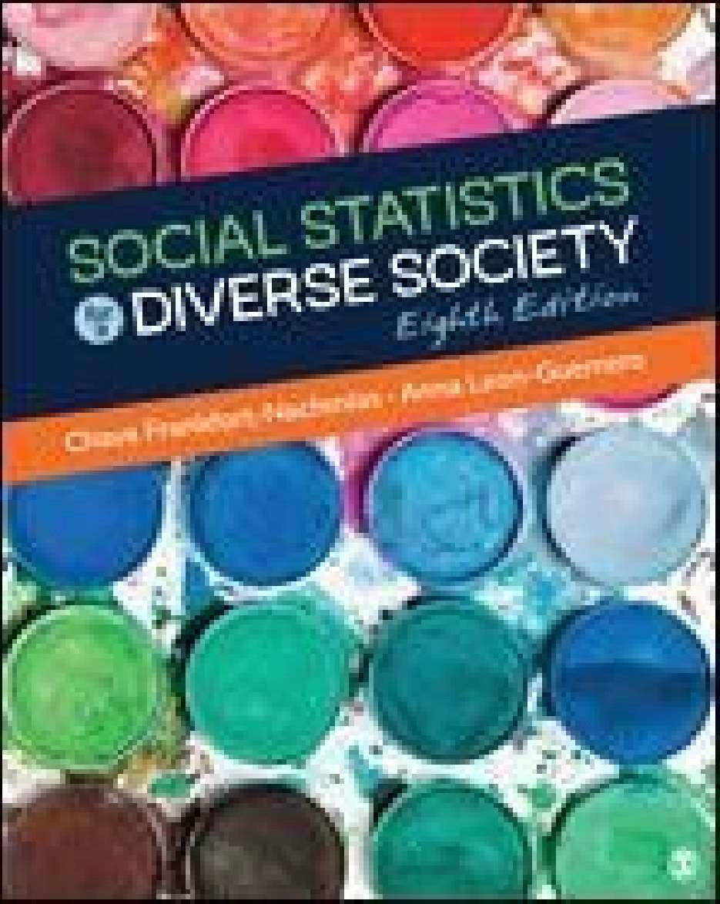
Textbook
Frankfort-Nachmias, C., & Leon-Guerrero, A. (2018). Social statistics for a diverse society (8th ed.). Thousand Oaks, CA: Sage. ISBN 978-1-5063-4720-2 [hereafter referenced as SSDS].

Calculator
You will need a simple calculator with a square root key.

Packages of Colored Candies
For several of the lessons, you will need (unopened) personal-sized packages of colored candies (e.g., M&M's® or Skittles®).

Course Delivery & Organization

The course will be delivered entirely online via Canvas. Each week's lessons and their associated discussion board post(s), assignment(s), and quiz(zes) (discussed below in the Course Requirements & Grading section of the syllabus) will be released on Monday at 8:00AM according to the attached schedule. Generally, each week's discussion board post(s), assignment(s), and quiz(zes) will be due on the Sunday following their release at 11:59PM.

To get started, click on the About Canvas link on the Welcome page of the course website in Canvas to learn about the course delivery platform. See also the short video 8 Tips for Succeeding in Your Online Class and other helpful resources on the Learn Anywhere UNT website.

To learn more about the course go to the Start Here heading on the Modules page of the course website in Canvas. In the Start Here section, you will find a downloadable .pdf of the course syllabus.

Course Technology & Skills

Minimum Technology Requirements
- Computer
- Reliable internet access
- Canvas Technical Requirements

Computer Skills & Digital Literacy
Course-specific technical skills learners must have to succeed in the course:

- Using Canvas
- Using email with attachments
- Saving documents as pdf files

Technical Assistance
Part of working in the online environment involves dealing with the inconveniences and frustration that can arise when technology breaks down or does not perform as expected. Here at UNT we have a Student Help Desk that you can contact for help with Canvas or other technology issues.

UIT Help Desk: UIT Student Help Desk website
Email: helpdesk@unt.edu
Phone: (940) 565-2324
In Person: 130 Sage Hall
Walk-In Availability: 8am-9pm
Telephone Availability:
- Sunday: noon-midnight
- Monday-Thursday: 8am-midnight
- Friday: 8am-8pm
- Saturday: 9am-5pm
Laptop Checkout: 8am-7pm

For additional support, visit Canvas Technical Help.

Course Requirements

Reading Assignments
You are responsible for reading the assigned materials during the week indicated on the attached course outline.

Weekly Lessons
Each week's lesson(s) can be found on the Modules page on the course website in Canvas. A list of associated assignments is provided on the last page of each lesson, and the assignments themselves can be found after the Lesson Files Download subheading for the lesson. Click through the arrows in the lesson, go over the learning checks, and make sure you understand the material before beginning the assignments. PLEASE NOTE: It is strongly recommended that you do not wait until Saturday and Sunday to begin your work for the week!

Weekly Discussions
There will be one discussion forum assignment for each lesson. Thus, since there are 10 lessons across the eight weeks of the course, there will be a total of 10 discussions. (See the attached course outline for specific dates.) For each lesson (except in Week 8), the discussion will open on Monday 8:00AM and close six days later on the following Sunday at 11:59PM. Discussions for lessons covered in Week 8 will open Monday 8:00AM in Week 7 and close Wednesday 11:59PM in Week 8. You can access a discussion by clicking on the dedicated link for it on the Discussions page of the course website in Canvas. Be sure to follow the posted instructions. Points will be deducted for discussions posted past their due date.
Every effort will be made to provide feedback on a discussion before the next week's discussion is due. All discussion forum assignments(@ 10 points each) will count towards your course grade for a total of

100 points.

Weekly Assignments
There will also be one assignment/problem set for each lesson. These assignments/problem sets will help you apply what you learn in "class" and prepare you for the quizzes and the final exam. The lessons can be found on the Modules page of the course website in Canvas. You can access a lesson's assignment by clicking on the dedicated submission link for it in the lesson on the Modules page of the course website in Canvas. For each lesson (except in Week 8), the assignment will open on Monday 8:00AM and close six days later on the following Sunday at 11:59PM. Assignments for lessons covered in Week 8 will open Monday 8:00AM in Week 7 and close Wednesday 11:59PM in Week 8. Your answers to the assignment's questions should be numbered and typed in complete sentences and all pages saved as one .pdf file using your last name and the lesson number (e.g., Yourlastnamelessonl).
Use the dedicated submission link provided for the assignment/problem set on the Modules page of the course website in Canvas to submit your .pdf file of answers as an attachment. Points will be deducted for assignments submitted past their due date. Every effort will be made to provide feedback on an assignment/problem set before the next week's assignment(s) are due. All lesson assignments(@ 10 points each) will count towards your course grade for a total of 100 points.

Weekly Quizzes
There will also be an online quiz for each week's lesson. You can access the quiz by clicking on the dedicated link for it on the Modules page of the course website in Canvas. For each lesson (except in Week 8), the quiz will open on Monday 8:00AM and close six days later on the following Sunday at 11:59PM. Quizzes for lessons covered in Week 8 will open Monday 8:00AM in Week 7 and close Wednesday 11:59PM in Week 8. You are given three attempts for each quiz. The attempts are open book and notes and will not be timed. Only the attempt with the highest grade will be used towards your course grade. However, please note that each time you take a quiz the multiple choice, true/false, matching, and fill-in-the-blank questions will be randomly drawn from that week's quiz item pool.
Therefore, you may get a slightly different set of questions each time you take it. Permission to "make­ up" a missed quiz will only be given for university-approved reasons. All lesson quizzes(@ 10 points each) will count towards your course grade for a total of 100 points.

Getting Help with a Post, Assignment, or Quiz Question
If you need help with a post, assignment/problem set, or quiz question, contact the instructor by using the Inbox button in Canvas. When you send your message to the instructor using this function, it will go to the instructor's UNT email address. Every effort will be made to respond to your email within 36 hours. You may also make an appointment to meet with the instructor online via Zoom. PLEASE NOTE: You may not copy another student's work or allow another student to copy yours. Both giving/getting unauthorized help and copying another student's work are violations of UNT's Code of Student Conduct.

Final Examination
There will be a final exam(@ 100 points) for a total of 100 points. Approximately two-thirds of the questions on the exam will come from the weekly quiz question pools. You can access the exam by clicking on the dedicated submission link for each exam on the Modules page of the course website in Canvas. The exam is open book and open notes. The exam is timed (120 minutes) and can be accessed only one time within the scheduled time window (i.e., not multiple times as with the weekly quizzes). Thus, please read the on-screen instructions carefully before you click "Begin." The final exam for the course will be released Thursday, July 1st at 8:00AM and close on Friday, July 2nd at 11:59PM. Make sure you are using a reliable internet connection. Permission to "make-up" a missed exam will only be

given for university-approved reasons.

Server Unavailability or Other Technical Difficulties
The University is committed to providing a reliable online course system to all users. However, in the event of any unexpected server outage or any unusual technical difficulty which prevents students from completing a time sensitive assessment activity, the instructor will extend the time windows and provide an appropriate accommodation based on the situation. Students should immediately report any problems to the instructor and contact the UNT Student Help Desk: helpdesk@unt.edu or (940) 565- 2324 and obtain a ticket number. The instructor and the UNT Student Help Desk will work with the student to resolve any issues at the earliest possible time.

Evaluation

Point values for each of the course requirements and the grading scale for the course are given below.

Point Values for Course Requirements
Requirement | Possible Points
Lesson Discussions (10@ 10 points each) | 100
Lesson Assignments (10@ 10 points each) | 100
Lesson Quizzes (10@ 10 points each) | 100
Final Exam (1 @ 100 points) | 100
TOTAL | 400

Course Grading Scale
Total Points Earned | Final Course Grade
360 or more | A
320-359 | B
280-319 | C
240- 279 | D
239 or fewer | F

UNT Policies

Academic Integrity
Academic Integrity Standards and Consequences. According to UNT Policy 06.003, Student Academic Integrity, academic dishonesty occurs when students engage in behaviors including, but not limited to cheating, fabrication, facilitating academic dishonesty, forgery, plagiarism, and sabotage. A finding of academic dishonesty may result in a range of academic penalties or sanctions ranging from admonition to expulsion from the University. In this course, a graded assignment compromised by academic dishonesty will earn a zero.

Disability Access
UNT makes reasonable academic accommodation for students with disabilities. Students seeking reasonable accommodation must first register with the Office of Disability Access (ODA) to verify their eligibility. If a disability is verified, the ODA will provide a student with an accommodation letter to be delivered to faculty to begin a private discussion regarding one's specific course needs. Students may request accommodations at any time, however, ODA notices of accommodation should be provided as

early as possible in the semester to avoid any delay in implementation. Note that students must obtain a new letter of accommodation for every semester and must meet with each faculty member prior to implementation in each class. For additional information, refer to the Office of Disability Access.

Prohibition of Discrimination, Harassment, and Retaliation

According to UNT Policy 16.004, Prohibition of Discrimination, Harassment, and Retaliation, UNT prohibits discrimination and harassment because of race, color, national origin, religion, sex, sexual orientation, gender identity, gender expression, age, disability, genetic information, veteran status, or any other characteristic protected under applicable federal or state law in its application and admission processes; educational programs and activities; employment policies, procedures, and processes; and university facilities. The University takes active measures to prevent such conduct and investigates and takes remedial action when appropriate.

Emergency Notification & Procedures

UNT uses a system called Eagle Alert to quickly notify students with critical information in the event of an emergency (i.e., severe weather, campus closing, and health and public safety emergencies like chemical spills, fires, or violence). In the event of a university closure, please refer to the course website on Canvas for contingency plans for covering course materials.

Acceptable Student Behavior

Student behavior that interferes with an instructor's ability to conduct a class or other students' opportunity to learn is unacceptable and disruptive and will not be tolerated in any instructional forum at UNT. Students engaging in unacceptable behavior will be directed to leave the classroom and the instructor may refer the student to the Dean of Students to consider whether the student's conduct violated the Code of Student Conduct. The University's expectations for student conduct apply to all instructional forums, including University and electronic classroom, labs, discussion groups, field trips, etc. Visit UNT's Code of Student Conduct to learn more.

Access to Information - Eagle Connect

Students' access point for business and academic services at UNT is located at: my.unt.edu. All official communication from the University will be delivered to a student's Eagle Connect account. For more information, please visit the website that explains Eagle Connect and how to forward e-mail
Connect.

Policy on Server Unavailability or Other Technical Difficulties

The University of North Texas is committed to providing a reliable online course system to all users. However, in the event of any unexpected server outage or any unusual technical difficulty which prevents students from completing a time sensitive assessment activity, the instructor will extend the time windows and provide an appropriate accommodation based on the situation. You should immediately report any problems to the instructor and also contact the UNT Student Help Desk: helpdesk@unt.edu or (940) 565-2324. Obtain, record, and retain your incident report number from the UNT Student Help Desk. The instructor and the UNT Student Help Desk will work with you to resolve any issues at the earliest possible time.

Retention of Student Records

Student records pertaining to this course are maintained in a secure location by the instructor of record. All records such as exams, answer sheets (with keys), and written papers submitted during the duration of the course are kept for at least one calendar year after course completion. Coursework completed

via the Canvas on-line system, including grading information and comments, is also stored in a safe electronic environment. You have a right to view your individual record; however, information about your records will not be divulged to other individuals without the proper written consent. You are encouraged to review the Public Information Policy and the Family Educational Rights and Privacy Act (FERPA) laws and the University's policy. See UNT Policy 04.008, Records Management and Retention, for additional information.

Sexual Assault Prevention
UNT is committed to providing a safe learning environment free of all forms of sexual misconduct, including sexual harassment sexual assault, domestic violence, dating violence, and stalking. Federal laws (Title IX and the Violence Against Women Act) and UNT policies prohibit discrimination on the basis of sex, and therefore prohibit sexual misconduct. If you or someone you know is experiencing sexual harassment, relationship violence, stalking, and/or sexual assault, there are campus resources available to provide support and assistance. UNT's Survivor Advocates can assist a student who has been impacted by violence by filing protective orders, completing crime victim's compensation applications, contacting professors for absences related to an assault, working with housing to facilitate a room change where appropriate, and connecting students to other resources available both on and off campus. The Survivor Advocates can be reached at SurvivorAdvocate@unt.edu or by calling the Dean of Students Office at (940) 565-2648. Additionally, alleged sexual misconduct can be non-confidentially reported to the Title IX Coordinator at oeo@unt.edu or at (940) 565-2759.

Student Evaluation Administration Dates
Student feedback is important and an essential part of participation in this course. The student evaluation of instruction is a requirement for all organized classes at UNT. The survey will be made available during weeks 13, 14 and 15 of the long semesters to provide students with an opportunity to evaluate how this course is taught. For Summer 8Wl 2021, the surveys will be made available June 25 - July 1. Students will receive an email from "UNT SPOT Course Evaluations via IASystem Notification" (no-reply@iasystem.org) with the survey link. Students should look for the email in their UNT email inbox. Simply click on the link and complete the survey. Once students complete the survey they will receive a confirmation email that the survey has been submitted. For additional information, please visit the SPOT website or email spot@unt.edu.

Student Verification
UNT takes measures to protect the integrity of educational credentials awarded to students enrolled in distance education courses by verifying student identity, protecting student privacy, and notifying students of any special meeting times/locations or additional charges associated with student identity verification in distance education courses. See UNT Policy 07-002 Student Identity Verification, Privacy, and Notification and Distance Education Courses.

Important Notice for F-1 Students taking Distance Education Courses

Federal Regulation
To read detailed Immigration and Customs Enforcement regulations for F-1 students taking online courses, please go to the Student and Exchange Visitor Program website. The specific portion concerning distance education courses is located at Title 8 CFR 214.2 Paragraph (f) (6) (G).

The paragraph reads:
For F-1 students enrolled in classes for credit or classroom hours, no more than the equivalent of one

class or three credits per session, term, semester, trimester, or quarter may be counted toward the full course of study requirement if the class is taken on-line or through distance education and does not require the student's physical attendance for classes, examination or other purposes integral to completion of the class. An on-line or distance education course is a course that is offered principally through the use of television, audio, or computer transmission including open broadcast, closed circuit, cable, microwave, or satellite, audio conferencing, orcomputer conferencing. If the F-1 student's course of study is in a language study program, no on-line or distance education classes may be considered to count toward a student's full course of study requirement.

University of North Texas Compliance
To comply with immigration regulations, an F-1 visa holder within the United States may need to engage in an on-campus experiential component for this course. This component (which must be approved in advance by the instructor) can include activities such as taking an on-campus exam, participating in an on-campus lecture or lab activity, or other on-campus experience integral to the completion of this course.

If such an on-campus activity is required, it is the student's responsibility to do the following:
- Submit a written request to the instructor for an on-campus experiential component within one week of the start of the course.
- Ensure that the activity on campus takes place and the instructor documents it in writing with a notice sent to the UNT International Student and Scholar Services (ISSS) Office. ISSS has a form available that you may use for this purpose.

Because the decision may have serious immigration consequences, if an F-1 student is unsure about their need to participate in an on-campus experiential component for this course, they should contact the UNT ISSS Office (internationaladvising@unt.edu) to get clarification before the one-week deadline.

Academic Support & Student Services

Student Support Services
- Student Health and Wellness Center
- Counseling and Testing Services
- UNT Care Team
- UNT Psychiatric Services
- Individual Counseling
- Registrar
- Financial Aid
- Student Legal Services
- Career Center
- Multicultural Center
- Counseling and Testing Services
- Pride Alliance
- UNT Food Pantry
Academic Support Services
- Academic Resource Center

- Academic Success Center
- UNT Libraries
- Writing Lab

NOTE: The following schedule is subject to change. Changes will be announced and posted in Canvas.

Weekly Class Schedule

!week Opie !Reading Assignment !Due !Released

Weekl  May 10-  May 16 | Welcome Letter Review Syllabus Lesson 1, The What & Why of Statistics  Lesson 2, Frequency/ Percentage Distributions & Graphs | SSDS, Chapters 1 & 2 | Due 05/16, 11:59PM  Lesson 1 Post Lesson lAssignment Lesson lQuiz Lesson 2 Post  Lesson 2 Assignment  Lesson 2 Quiz | Lesson 1 & Lesson 2
Week2  May 17-  May 23 | Lesson 3, Measures of Central Tendency &  Variability | SSDS, Chapters 3 & 4 | Due 05/23, 11:59PM  Lesson 3 Post Lesson 3Assignment | Lesson 3
 |  |  | Lesson 3 Quiz
Week3  May 24-  May 30 | Lesson 4, The Normal Curve | SSDS, Chapters 5 & 6 | Due 05/30, 11:59PM  Lesson 4 Post  Lesson 4 Assignment | Lesson 4  &  Lesson 5
 | Lesson 5, Sampling &  Sampling Distribution |  | Lesson 4 Quiz  Lesson 5 Post
 |  |  | Lesson 5 Assignment
 |  |  | Lesson 5 Quiz
Week4 | Lesson 6, Estimating | SSDS, Chapter 7 | Due 06/06, 11:59PM | Lesson 6
May 31- | Population Means |  | Lesson 6 Post
June 6 |  |  | Lesson 6 Assignment
 |  |  | Lesson 6 Quiz
Weeks | Lesson 7, Introduction to | SSDS, Chapter 8 | Due 06/13, 11:59PM | Lesson 7
June 7 -  June 13 | Hypothesis Testing - The  One-Sample t Test |  | Lesson 7 Post  Lesson 7 Assignment
 |  |  | Lesson 7 Quiz
Week6 | Lesson 8, Hypothesis | SSDS, Chapter 8 | Due 06/20, 11:59PM | Lesson 8
June 14- | Testing - The Two-Sample |  | Lesson 8 Post
June 20 | tTest |  | Lesson 8Assignment
 |  |  | Lesson 8 Quiz
Week7  June 21-  June 27 | Lesson 9, The Bivariate Table | SSDS, Chapter 9 | Due 06/27, 11:59PM  Lesson 9 Post  Lesson 9 Assignment | Lesson 9  &  Lesson 10
 |  |  | Lesson 9 Quiz
Week8  June 28-  July 2 | Lesson 10, The Chi- Squared Test | SSDS, Chapter 10 | Due WED 06/30, 11:59PM  Lesson 10 Post Lesson lOAssignment Lesson 10 Quiz | Final Exam (Thursday, July 1 at 8:00AM)
Due FRI 07 /02, 11:59PM
Final Exam

